## Embedded Systems Diploma 54

## Final Project Report

## Prepared by :

## Solwan Shokry Ahmed

## Supervised by:

## Eng. Mohamed Tarek

1. Building Modules Drivers using Static& Dynamic Configuration:

AVR ATmega16 Timer Module Driver:

**Static Configurations:**

There are nothing to be configured statically in which cannot be changed during run-time; no hardware limitations to stick with once the program runs, everything can be changed.

So, in order to make this driver as useful as possible, all features of timer module included in the data sheet of the ATmega16 micro-controller will be supported.

**Dynamic Configurations**:

1. Timer number

Choose which one of the three timers that exist on-chip with the MCU to work with:

* Timer0: 8-bit timer

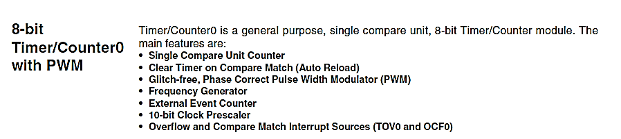

**Timer/Counter Clock Sources**

The Timer/Counter can be clocked by an internal or an external clock source. The clock source is selected by the clock select logic which is controlled by the clock select (CS02:0) bits located in the Timer/Counter Control Register (TCCR0).

**Modes of Operation**

The mode of operation, i.e., the behaviour of the Timer/Counter and the Output Compare pins, is defined by the combination of the Waveform Generation mode (WGM01:0) and Compare Output mode (COM01:0) bits. The Compare Output mode bits do not affect the counting sequence, while the Waveform Generation mode bits do. The COM01:0 bits control whether the PWM output

generated should be inverted or not (inverted or non-inverted PWM). For non-PWM modes the COM01:0 bits control whether the output should be set, cleared, or toggled at a compare match.

**Timer/Counter Control Register – TCCR0**

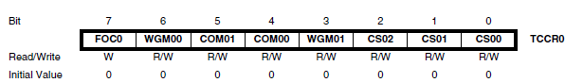

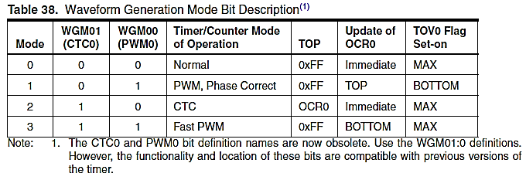

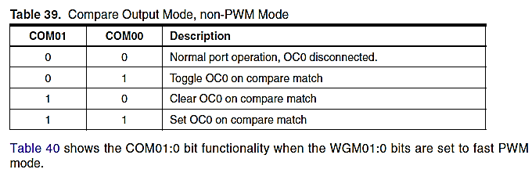

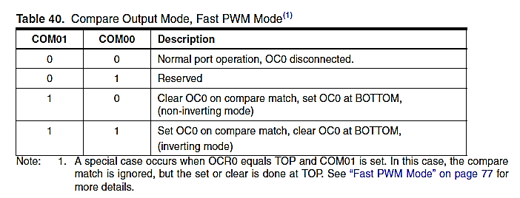

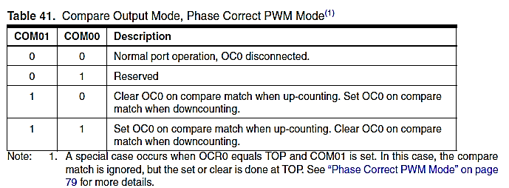

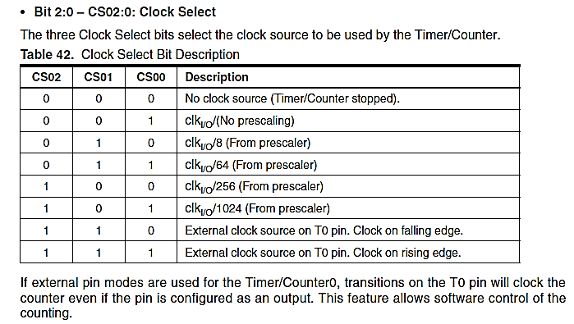

* Timer1: 16-bit timer

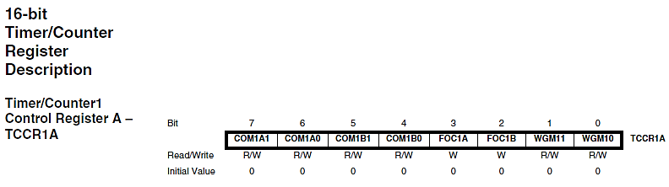

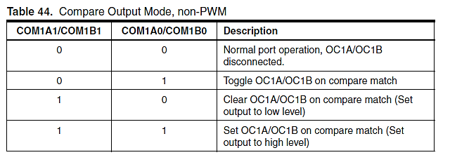

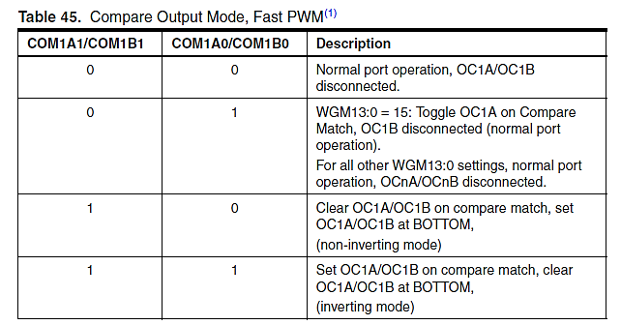

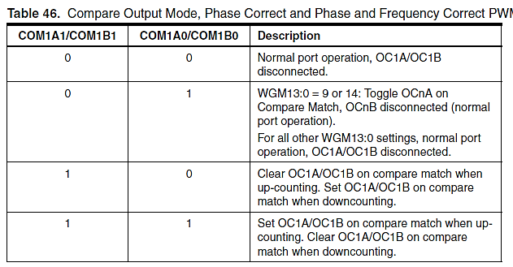

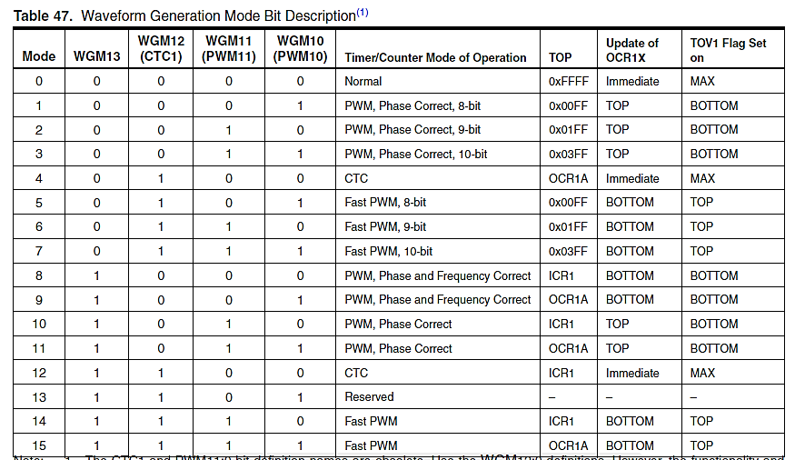

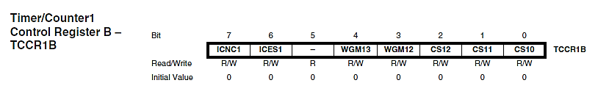

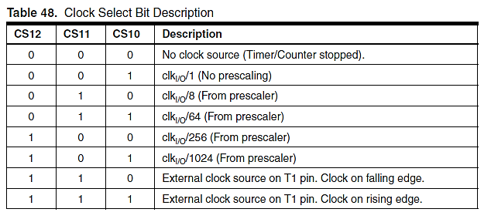

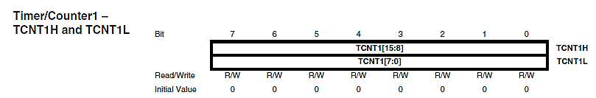

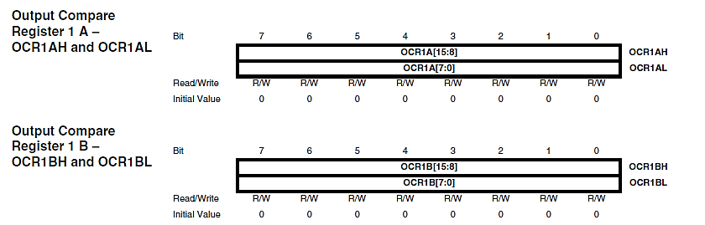

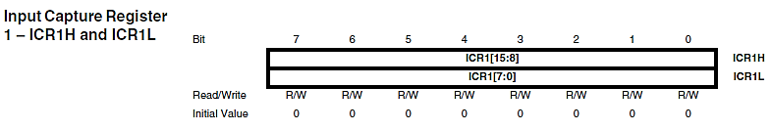

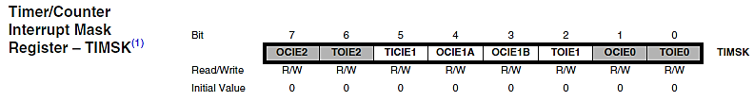

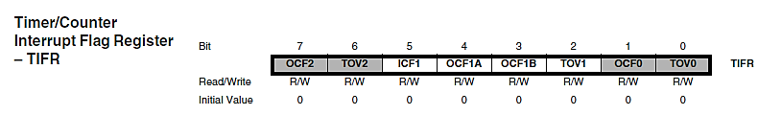

* Timer2: 8-bit timer